**Database Project Part 4b**

**Data Manipulation Language Scripts**

1. Add a new column of type ‘ENUM’. Document in your report what the purpose of this column is, and what the choices represent. Add a constraint that prevents null values. Take screen captures of your table before and after the column is created.

**Answer:**

**Here we add gender with enum data type,because we should know about the Customer gender,which will help us to which gender is more interested about our product**

**Here are two options which will choose the customer. One is male another one is female.**



2. Insert a new record of data into the same table that you added the new column. This requires two steps:

a) show that the system throws an error if you try to leave the required ‘enum’ value blank.

b) modify your insert to include a valid entry so that the data works properly.

If you can fit all of this in one screen capture, that would be acceptable.

**Answer:**





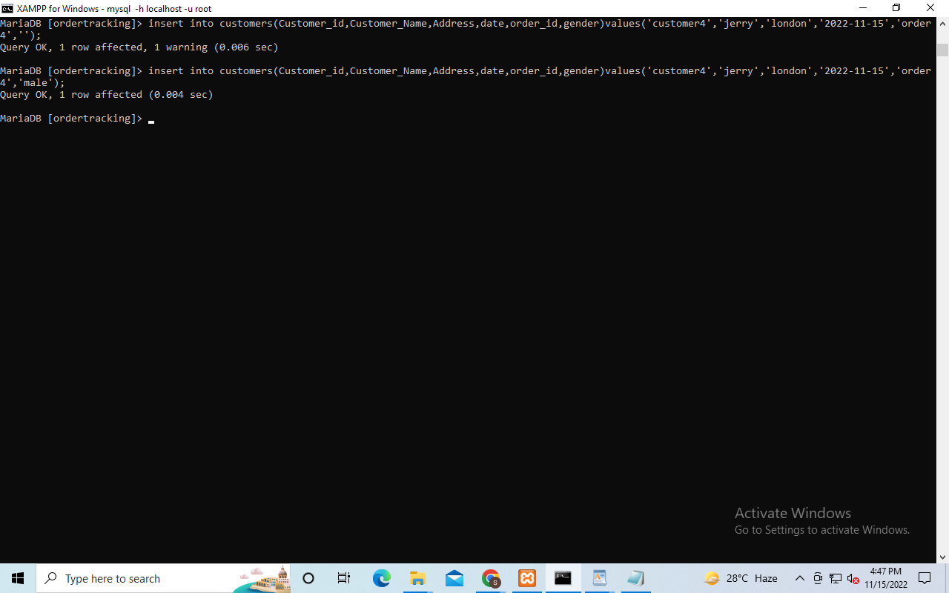

3. In your report, explain what changes you can make to each column of the record you just added in #2. Then, modify that data to show those changes. Include a screen capture that shows the ‘after’ result. The ‘before’ state is already documented from step 2.

Answer:

**before**

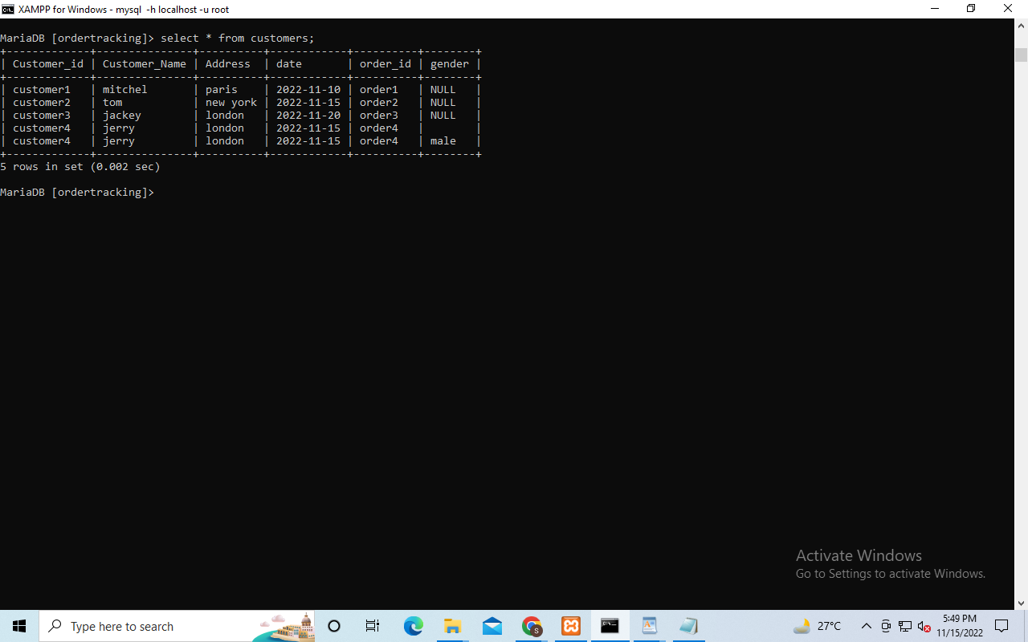

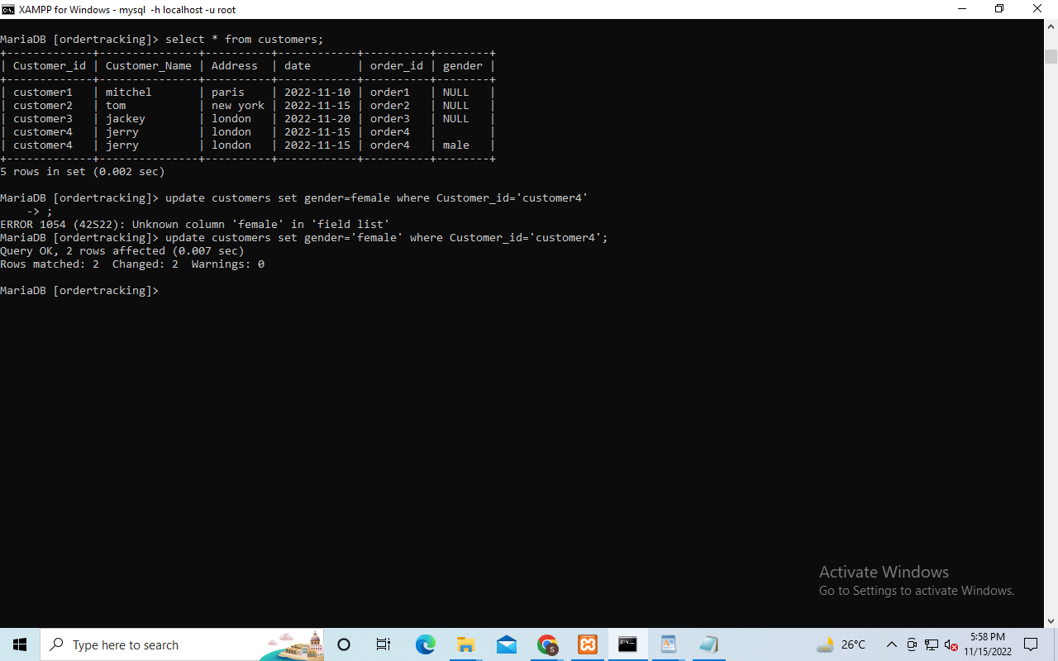

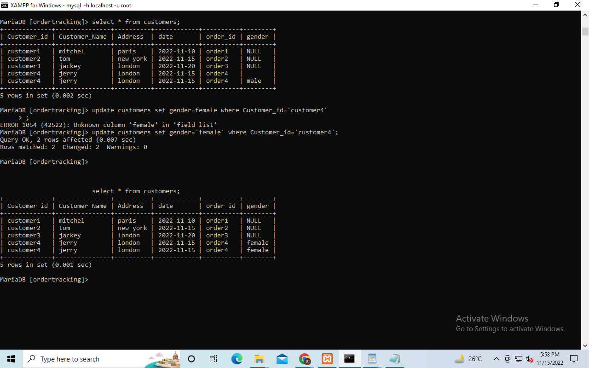

4. Delete the new record. Use the ‘where’ clause to specifically select just the new record. Show a screen capture of the command and the ‘after’ result.

**Answer:**



5. Demonstrate the use of the ‘AUTO_INCREMENT’ constraint by adding a record to a table with this feature. If you do not have this feature already enabled, then alter a table to include a new column. Show a screen capture of the table before you add the new record, and another screen capture after you add the new record to demonstrate the autoincrement.

**Answer:**

**Auto_increment always allows us a unique number for identifying the particular record.It’s always automatically generated the unique number when a new record is added into the database table.**



**BEFORE ADD DATA**

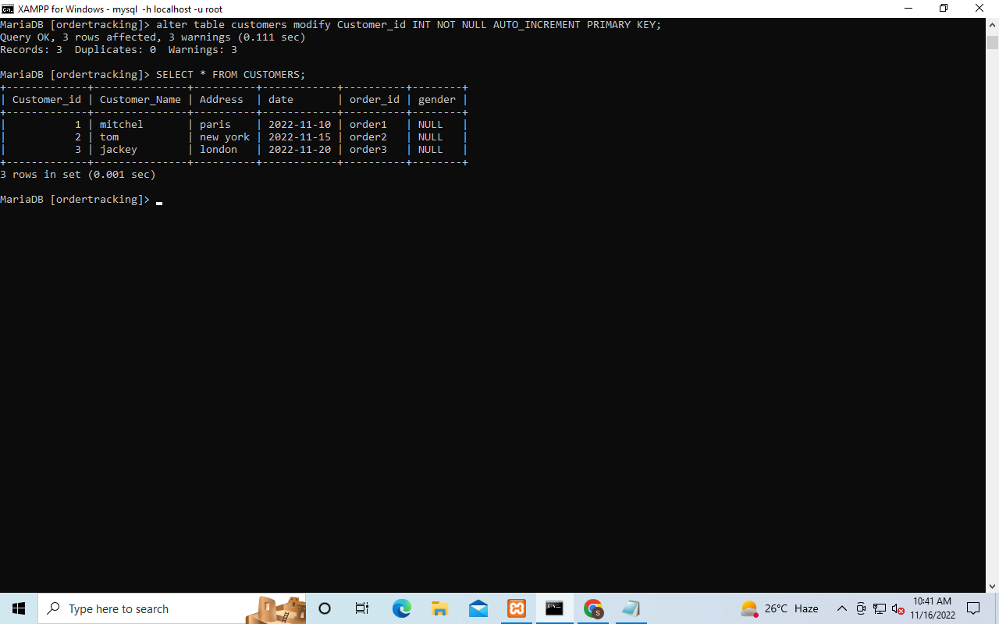

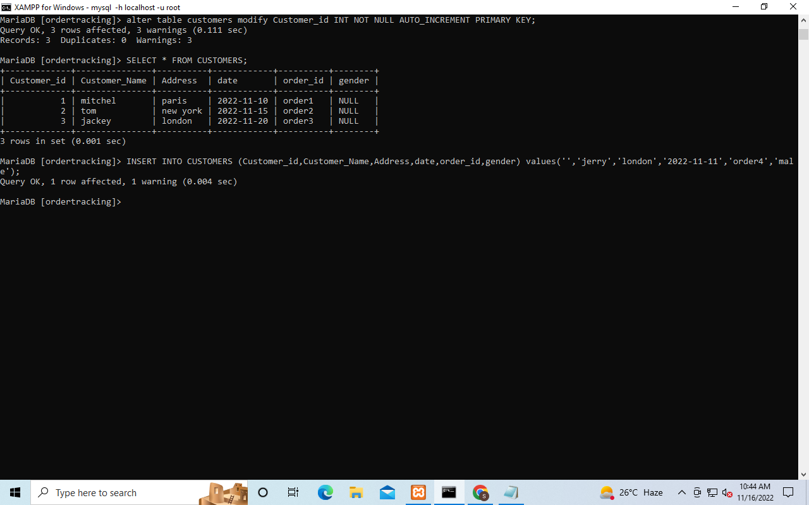

**after add record**

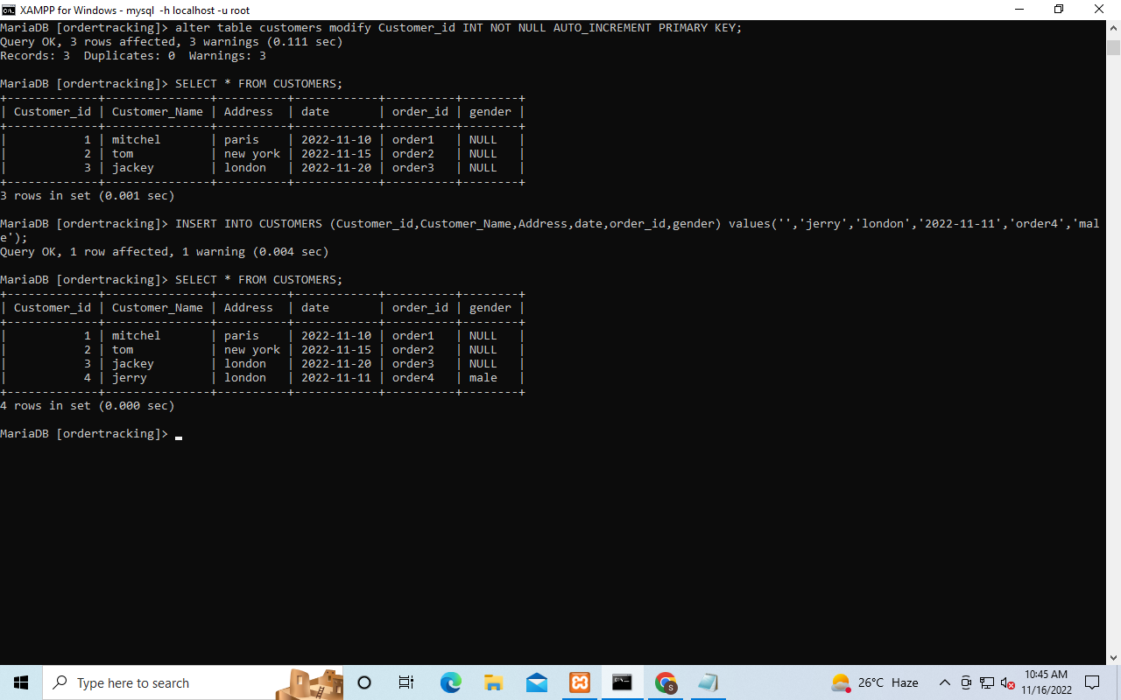

6. Repeat step 5, except demonstrate the use of the ‘DEFAULT’ constraint by adding a record to a table with this feature. You may need to add a column with this feature if you don’t already have it. Prove that adding a new record of data without this value during entry will still get the default value after your ‘insert’ command executes.

**Answer:**

**When a column is always the same value even if a new record is inserted the value of the column will be the same for this purpose we use Default constraint.**





